**Ideation Phase**

**Define the Problem Statements**

|  |  |
| --- | --- |
| Date | 30 May 2025 |
| Team ID | LTVIP2025TMID42578 |
| Project Name | ResolveNow |
| Maximum Marks | 2 Marks |

**Customer Problem Statement Template:**

Create a problem statement to understand your customer's point of view. The Customer Problem Statement template helps you focus on what matters to create experiences people will love.

A well-articulated customer problem statement allows you and your team to find the ideal solution for the challenges your customers face. Throughout the process, you’ll also be able to empathize with your customers, which helps you better understand how they perceive your product or service.

Reference: <https://miro.com/templates/customer-problem-statement/>

**Example:**

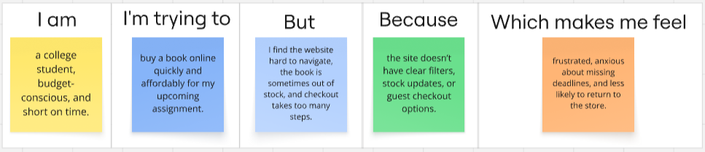

**🔹 Customer Problem Statement – ResolveNow**

| **Problem Statement (PS)** | **I am (Customer)** | **I’m trying to** | **But** | **Because** | **Which makes me feel** |
| --- | --- | --- | --- | --- | --- |
| **PS-1** | a citizen/customer facing an issue | submit a complaint and get it resolved quickly | I don’t know if my complaint is assigned or being worked on | there is no visibility or status update once I submit it | frustrated, ignored, and powerless |
| **PS-2** | a customer who submitted a complaint | follow up with the responsible support agent | I have no idea who is handling my complaint | the system doesn’t show the assigned agent or allow communication | anxious and disconnected |
| **PS-3** | a first-time platform user | report a problem about a public utility or service | I’m unsure what category to select or where to route it | the system is too generic and doesn’t guide me properly | confused and discouraged |
| **PS-4** | a busy support agent | handle complaints within SLA timelines | I keep receiving tickets outside my skill area or too many at once | there is no smart assignment or load balancing mechanism | overwhelmed and demotivated |
| **PS-5** | an admin managing a support team | ensure complaints are resolved fairly and timely | I can’t monitor agent workload or performance easily | the system lacks dashboards or clear routing history | stressed and reactive |